|  |  |  |  |
| --- | --- | --- | --- |
| Name |  | Date |  |

1. Identify the pins on an eight pin relay.

|  |  |
| --- | --- |
|  | List the Terminal number Pairs |
| Coil ______ |
| Normally Open Contacts ________ _________ |
| Normally Closed Contacts ________ _________ |

1. What is the purpose of a shading coil on a relay? ____________________
2. Give one advantage of using a solid state relay? ____________________
3. Why would you use contactors over a clapper type relay? ____________________
4. What is the difference between a contactor and a motor starter? _____________________
5. Draw a wired circuit that will control three lights. When a selector switch is in the left position and a normally open pushbutton is pressed, the green light shall come on. When the button is released, the light shall stay on. When the selector switch is in the right position, the yellow light shall come on when the button in pressed. If at any time a normally closed pushbutton is pressed, the yellow and green lights will go out and the red light shall come on. The storeroom only has an 11 pin relay, so you must use that for your solution. Use all rung references, wire numbers, and terminal numbers for this 24 VAC control circuit.

|  |  |  |  |  |  |  |  |  |
| --- | --- | --- | --- | --- | --- | --- | --- | --- |
|  |  |  |  |  |  |  |  |  |
|  |  |  |  |  |  |  |  |  |
|  |  |  |  |  |  |  |  |  |
|  |  |  |  |  |  |  |  |  |
|  |  |  |  |  |  |  |  |  |
|  |  |  |  |  |  |  |  |  |
|  |  |  |  |  |  |  |  |  |



1. Identify the parts of a relay.
   1. _____________
   2. _____________
   3. _____________
   4. _____________
   5. _____________

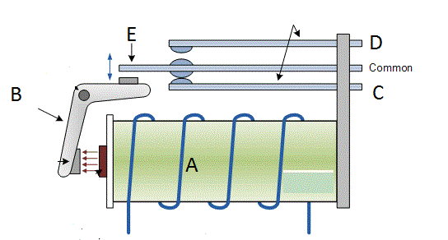

1. Review the following schematic. H is a relay that is to be used to control a 120V horn. S is a relay that is used to silence the horn. Complete the following equations.

H = ________________________

S = ________________________

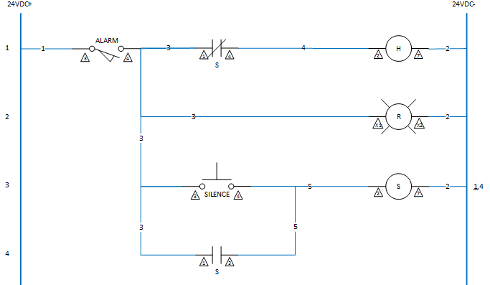

1. Without seeing any more of the schematic below, can CR be an 8-pin relay? Why or why not.

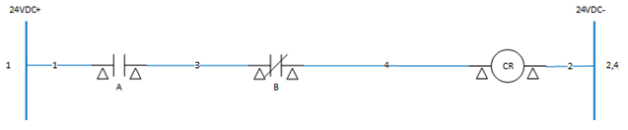

1. Complete the truth table below for the given schematic.

|  |  |  |  |
| --- | --- | --- | --- |
| A | B | C | D |
| 0 | 0 | 0 |  |
| 1 | 0 | 0 |  |
| 0 | 1 | 0 |  |
| 1 | 1 | 0 |  |
| 0 | 0 | 1 |  |
| 1 | 0 | 1 |  |
| 0 | 1 | 1 |  |
| 1 | 1 | 1 |  |

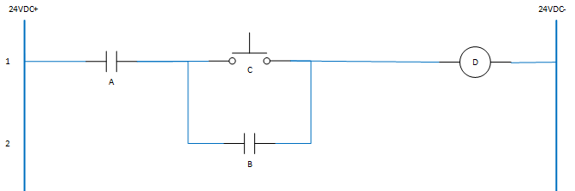

1. Timing Relays come in two basic types.
   1. On-Delay, Off-Delay
   2. DOE, DODE
   3. A and B
   4. None of the Above
2. What is the difference between a control relay and a timing relay
   1. A timing relay only comes in 11-pin form where control relays are 8 and 11 pins
   2. Timing relays delay changing states when the coil is energized verse control relay change immediately.
   3. Timing relays have both immediate contact changes and delayed contact changes
   4. B and C
   5. All of the Above

|  |  |
| --- | --- |
| 1. Identify the symbol to the right |  |
| a. On-Delay normally open |
| b. On-Delay normally closed |
| c. Off-Delay normally open |
| d. Off-Delay normally closed |

1. What type of pressure switch is suited for low pressure applications?
   1. Diaphragm
   2. Bellows
   3. Piston
   4. None of the above
2. What doesn’t a mercury bulb float switch offer that other methods contain?
3. A differential range
4. Flexibility
5. Low cost application
6. All of the above
7. What level sensing device is best used for turbulent or uneven material levels?
8. Supersonic level sensor
9. Microwave level sensor
10. Bubbler
11. Strain gauge

|  |  |
| --- | --- |
| 1. Identify the symbol to the right |  |
| a. normally open pressure switch |
| b. normally closed pressure switch |
| c. normally open float switch |
| d. normally closed float switch |

1. Calculate the pounds per square inch (PSI) of the water level in the following tank.



1. What is a drawback to a traditional limit switch?
   1. Only works in ambient temperature
   2. Needs to be re-adjusted often
   3. Has to physically touch the sensed object
   4. Is expensive
   5. None of the Above

|  |  |
| --- | --- |
| 1. Identify the switch to the right |  |
| a. Limit Switch |
| b. Liquid Flow Switch |
| c. Proximity Switch |
| d. Airflow Switch |

1. List three different detection methods used in the design of proximity switches?
   1. _________________________
   2. _________________________
   3. _________________________
2. What is a transducer?
   1. Another name for a switch or two state device
   2. A proximity switch used to detect metal objects
   3. A device that sends an on/off signal based on what it is sensing
   4. A device that sends a varying signal based on what it is sensing
3. When would you use a proximity switch that is capacitive over the other types?
   1. When cost isn’t an issue
   2. When the material is not conductive
   3. When the material changes from one type to another
   4. All of the above
4. What is the easiest material for a proximity switch to detect?
   1. Glass
   2. Metal
   3. Plastic
   4. All the above
5. Why would you choose a photo detector over a limit switch or proximity switch?
   1. Cost
   2. Speed
   3. Much easier to install
   4. Does not touch object being detected
6. Match the symbols to the description

|  |  |
| --- | --- |
| * 1. Photovoltaic |  |
| * 1. Proximity Switch |  |
| * 1. Flow Switch |  |
| * 1. Limit Switch |  |

1. What type of device changes resistance when hit by light?
   1. Photovoltaic
   2. Photoemissive
   3. Photoconductive
   4. All of the above
2. What is the purpose of a Hand-Off-Auto circuit?
   1. Permits operator to select between automatic or manual operation of a motor
   2. Offers a possibility to lock-out a motor
   3. An operator can gain local control and take it away from the control system
   4. All of the Above
3. Describe to operation of the following circuit?



* 1. The selector switch in the hand position
  2. The selector switch in the Off position
  3. The selector switch in the Auto position

1. Describe the difference between jogging and inching;

Jogging is

Inching is

1. How can jogging be accomplished in a control circuit?
   1. Using stop button with start button
   2. Using a selector switch and a normally open pushbutton
   3. Using a double-acting pushbutton
   4. B and C
   5. All of the above
2. Why is it better to use a control relay with a motor starter for a start/stop/jog circuit over using a double acting pushbutton?
   1. Ensures circuit is broken when jog button is pressed and released
   2. Control relay is more powerful
   3. Double acting pushbuttons break all the time
   4. It’s always better to use a relay over a pushbutton
3. What type of circuit is shown below? ___________________

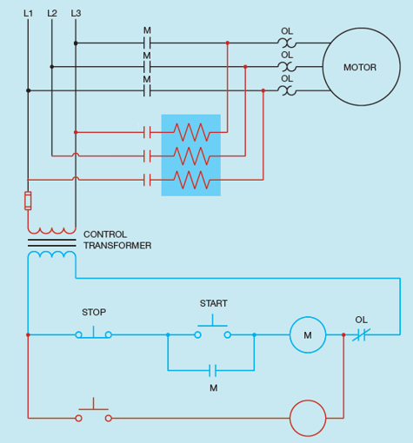

1. How can a three-phase motor be reversed?
2. To set up a three-phase reversing motor, list three components that you must have on the three phase side (do not list the motor itself);

|  |  |
| --- | --- |
| a. ________________  b. ________________  c. ________________ |  |

1. What is missing from the circuit below? Draw in missing components.

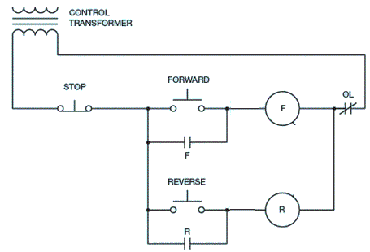

1. Below is a design for a Stop/Start/Jog circuit for a three phase motor. Will this circuit accomplish its intended function? Why or why not.



1. You’re given a 1HP motor that rotates at 1725 RPM that can be connected to both 220V and 440V. You are told that the motor draws 2.2A at 220V, what will be the current draw at 440V?

________________ Amps

1. Changing the voltage from 208V to 440V on a three phase motor will change the horsepower rating of the motor. True or False
2. Identify the following characteristics of a motor given its nameplate below.

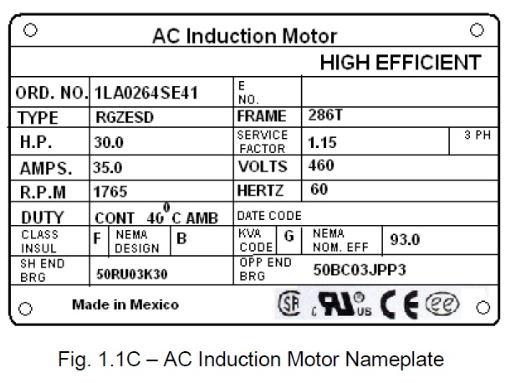

|  |  |
| --- | --- |
| Speed |  |
| NEC Code |  |
| Horsepower |  |

1. Can this motor be connected to more than one voltage? YES or NO

Explain Why ____________________________________________

1. Can you power this motor on single phase? YES or NO

Explain Why ____________________________________________

1. Can this motor run in a plant 24 hours a day, 7 days per week? YES or NO

Explain Why ____________________________________________

1. A 5 KVA buck/boost transformer can handle how many KVA per winding? _______________
2. A transformer that has a total 2:1 ratio and is supplied 240V on the primary will supply a voltage of ________________ volts on the secondary.
3. The _______________ winding usually has a smaller gage wire than the ______________ winding.
4. The power triangle consists of three measurements with three different units
   1. Apparent power is measured in _____________
   2. Reactive Power is measured in _____________
   3. Active Power is measured in _______________
5. What ratio produces the power factor?
   1. Active power/Apparent power
   2. Reactive power/Active power
   3. Active Power/Reactive power
   4. Reactive Power/Apparent power
6. A circuit whose voltage period starts before the current’s period would have what type of load?
7. Why are transformer cores made of insulated laminated iron cores?
   1. To eliminate hysteresis
   2. To force magnetic field lines to go in a certain direction
   3. To eliminate eddy currents
   4. It wouldn’t work if it wasn’t
8. Connect the given transformers below into a three phase delta to delta configuration. Make sure to polarized each transformer and denote H and X terminals.



1. In a delta configured primary of a 3 phase transformer, select the correct statement below.
   1. The line current equals the phase current
   2. The line voltage equals the phase voltage
   3. The line voltage equals the phase voltage times the square root of three.
   4. None of the above
2. In a wye configured secondary of a 3 phase transformer, select the correct statement below.
   1. The line current equals the phase current
   2. The line voltage equals the phase voltage
   3. The line current equals the phase voltage times the square root of three.
   4. None of the above